Assignment 35: Terraform
Objective
To create reusable Terraform infrastructure for a music-streaming application by provisioning an AWS EC2 server and an AWS RDS MySQL database, organize the configuration into multiple files and variables, manage the project with Git, document deployment steps in README.md, and identify best practices for team collaboration.

Requirements
- Terraform CLI
- AWS account with suitable EC2, RDS and networking permissions
- AWS credentials configured
- Git
- PowerShell/Terminal
- Text editor

Important AWS Cost & Security Note
EC2 and RDS are billable resources. RDS MySQL can incur charges even when used only for a practical. Free Tier eligibility depends on the AWS account and current AWS terms. Do not expose a production database publicly. Destroy resources after the practical if they are no longer needed.

Practical 1 – Install Terraform and Create Basic EC2 Configuration
Install Terraform for your operating system, open a new terminal, and verify the installation:
terraform --version
Expected output:
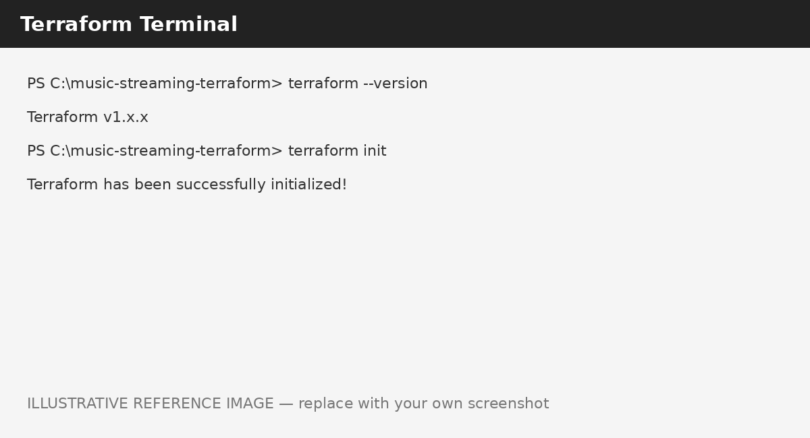Figure 1: Illustrative Terraform installation and version verification
Create the project directory:
mkdir music-streaming-terraform
cd music-streaming-terraform
Create main.tf:
terraform {
required_providers {
aws = {
source = "hashicorp/aws"
}
}
}
provider "aws" {
region = "us-east-1"
}
data "aws_ssm_parameter" "amazon_linux_2" {
name = "/aws/service/ami-amazon-linux-latest/amzn2-ami-hvm-x86_64-gp2"
}
resource "aws_instance" "music_streaming_server" {
ami = data.aws_ssm_parameter.amazon_linux_2.value
instance_type = "t2.micro"
tags = {
Name = "music-streaming-server"
}
}
The SSM Parameter Store lookup obtains an Amazon Linux 2 AMI appropriate for the selected region instead of relying on an old hard-coded AMI ID.
terraform init
terraform fmt
terraform validate
Result: A basic Terraform configuration was created for the music-streaming-server EC2 instance.

Practical 2 – Refactor into ec2.tf and variables.tf
Terraform loads all .tf files in the same directory. Organize the project as:
music-streaming-terraform/
├── main.tf
├── ec2.tf
└── variables.tf

main.tf
terraform {
required_providers {
aws = {
source = "hashicorp/aws"
}
}
}
provider "aws" {
region = "us-east-1"
}

variables.tf
variable "instance_type" {
description = "EC2 instance type"
type = string
default = "t2.micro"
}
variable "ami" {
description = "Amazon Linux 2 AMI ID for us-east-1"
type = string
}

ec2.tf
resource "aws_instance" "music_streaming_server" {
ami = var.ami
instance_type = var.instance_type
tags = {
Name = "music-streaming-server"
}
}

terraform.tfvars
instance_type = "t2.micro"
ami = "REPLACE_WITH_CURRENT_AMAZON_LINUX_2_AMI_ID"
Replace the AMI placeholder with a valid Amazon Linux 2 x86_64 AMI ID for us-east-1. AMI IDs are region-specific.
terraform fmt
terraform validate
terraform plan
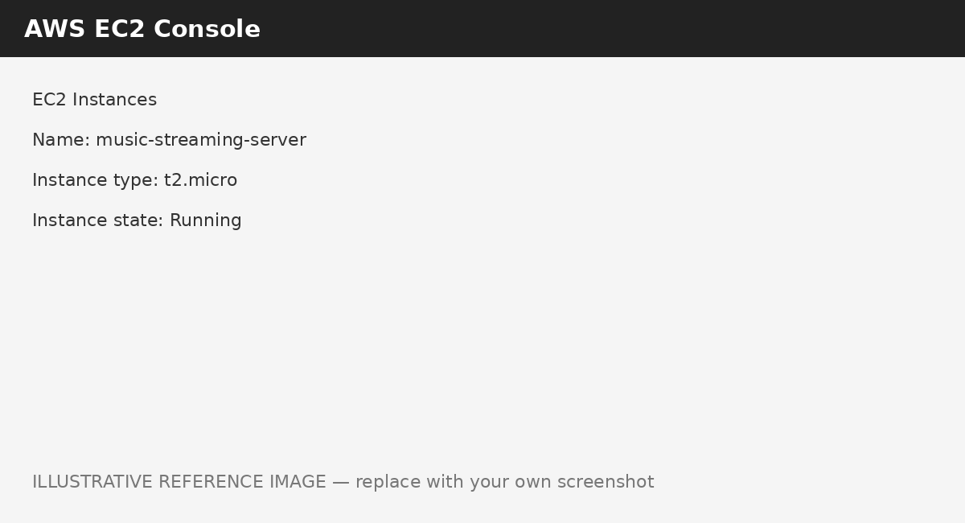
Figure 2: Illustrative EC2 console showing music-streaming-server
Result: The EC2 resource was separated into ec2.tf and the instance type and AMI became input variables.

Practical 3 – Add RDS MySQL and Output the Endpoint
Create db.tf. This classroom configuration discovers the default VPC and its subnets so the RDS subnet group can be created without hard-coding subnet IDs.

db.tf
data "aws_vpc" "default" {
default = true
}
data "aws_subnets" "default" {
filter {
name = "vpc-id"
values = [data.aws_vpc.default.id]
}
}
resource "aws_db_subnet_group" "playlist_db" {
name = "playlist-db-subnet-group"
subnet_ids = data.aws_subnets.default.ids
tags = {
Name = "playlist-db-subnet-group"
}
}
resource "aws_db_instance" "playlist_db" {
identifier = "playlist-db"
engine = "mysql"
engine_version = "8.0"
instance_class = "db.t3.micro"
allocated_storage = 20
storage_type = "gp2"
username = "admin"
password = var.db_password
db_subnet_group_name = aws_db_subnet_group.playlist_db.name
publicly_accessible = false
skip_final_snapshot = true
deletion_protection = false
tags = {
Name = "playlist-db"
}
}

variables.tf – add database password
variable "db_password" {
description = "RDS MySQL administrator password"
type = string
sensitive = true
}

terraform.tfvars – add password
db_password = "REPLACE_WITH_A_STRONG_DEMO_PASSWORD"
instance_type = "t2.micro"
ami = "REPLACE_WITH_CURRENT_AMAZON_LINUX_2_AMI_ID"
Do not commit terraform.tfvars when it contains passwords. Add it to .gitignore.

outputs.tf
output "database_endpoint" {
description = "RDS MySQL database endpoint"
value = aws_db_instance.playlist_db.endpoint
}
Apply the configuration:
terraform fmt
terraform validate
terraform plan
terraform apply
After apply, display the endpoint:
terraform output database_endpoint
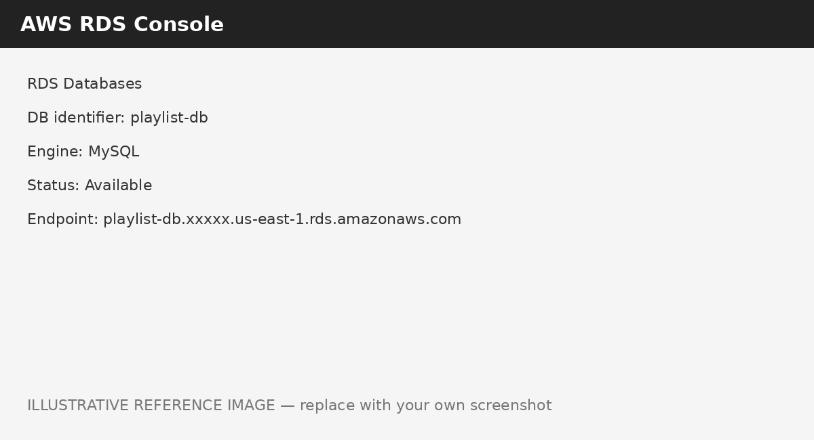
Figure 3: Illustrative RDS console showing playlist-db
Result: The playlist-db MySQL database was added and outputs.tf displays its endpoint after deployment.

Practical 4 – Git Repository and README.md
Initialize Git in the Terraform project directory:
git init
git status
git add .
git commit -m "Initial Terraform infrastructure"
git log --oneline
Create README.md containing:

README.md
# Music Streaming Terraform Infrastructure
## Overview
Provisions:
- EC2 instance: music-streaming-server
- RDS MySQL database: playlist-db
## Prerequisites
- Terraform
- AWS credentials
- Git
- us-east-1 access
## Deployment
terraform init
terraform fmt
terraform validate
terraform plan
terraform apply
## Required Variables
instance_type = "t2.micro"
ami = "<Amazon Linux 2 AMI ID for us-east-1>"
db_password = "<strong password>"
## Database Endpoint
terraform output database_endpoint
## Destroy
terraform destroy
Create .gitignore:
.terraform/
*.tfstate
*.tfstate.*
crash.log
terraform.tfvars
*.tfvars
git add README.md .gitignore
git commit -m "Add README and gitignore"
git status
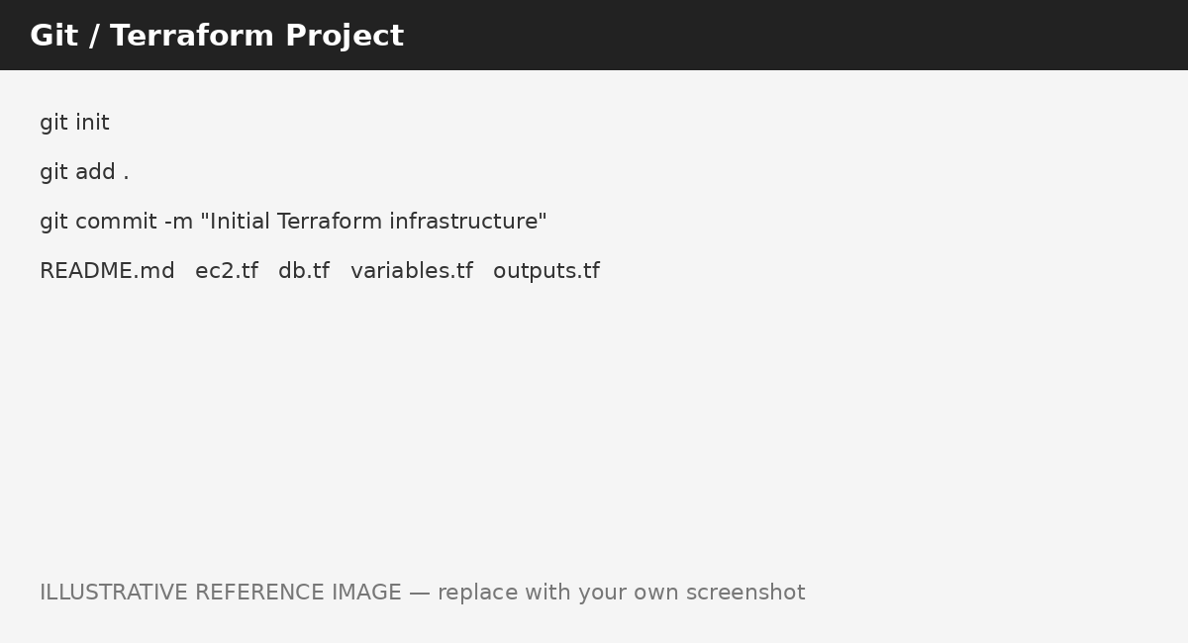
Figure 4: Illustrative Git and Terraform project workflow
Result: The project was initialized as a Git repository, configuration files were committed, and README.md documented deployment and variable requirements.

Practical 5 – Three Terraform Team Best Practices

1. Use Remote State and State Locking
Store Terraform state in a shared remote backend with appropriate locking/concurrency controls. This prevents developers from working from conflicting local state files and reduces the risk of simultaneous changes.

2. Use Git, Pull Requests and Code Review
Keep Terraform configuration in Git and review infrastructure changes through pull requests. This provides change history, peer review, accountability and safer collaboration.

3. Protect Secrets and Pin Dependencies
Never commit passwords, access keys or other secrets. Use sensitive variables and an appropriate secrets-management solution. Pin provider versions and review upgrades deliberately to reduce unexpected changes and broken deployments.

Recommended Project Structure
music-streaming-terraform/
├── main.tf
├── ec2.tf
├── db.tf
├── variables.tf
├── outputs.tf
├── terraform.tfvars # local only; do not commit
├── .gitignore
└── README.md

Overall Terraform Workflow
Configuration
↓
terraform init
↓
terraform fmt / validate
↓
terraform plan
↓
terraform apply
↓
AWS EC2 + RDS
↓
terraform output
↓
Database Endpoint

Screenshot Checklist
- 1. terraform --version output
- 2. main.tf / refactored Terraform project files
- 3. AWS EC2 console showing music-streaming-server
- 4. Terraform plan/apply output
- 5. AWS RDS console showing playlist-db
- 6. terraform output database_endpoint
- 7. Git commit and README.md
Photo note: The images in this document are illustrative reference photos, not proof of an actual run. Replace them with your own screenshots for final submission.

Cleanup
When the practical is complete, remove the AWS resources if they are no longer required:
terraform destroy
Review the resources and type yes when prompted. This is especially important for RDS because it may incur ongoing charges.

Conclusion
The Terraform configuration was developed from a basic EC2 deployment into a reusable multi-file infrastructure project. The EC2 instance was named music-streaming-server, its AMI and instance type were parameterized, and an RDS MySQL database named playlist-db was added with an output for its endpoint. Git and README.md provided version control and documentation, while remote state, code review, and secure secret/dependency management were identified as key team practices.

